SKILL AND JOB RECOMMENDER **PNT2022TMID43088**

Setting up Application Environment Docker CLI Installation

|  |  |
| --- | --- |
| Date | 03 November 2022 |
| Team ID | **PNT2022TMID43088** |
| Project Name | Customer care registry. |

**Step 1.** Download Docker from docker.com and install it by running the Docker Desktop Installer.exe ﬁle.

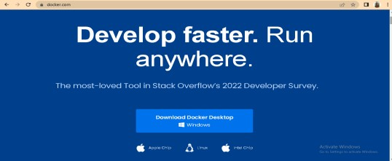

**Step 2.** Goto hub.docker.com register and create an account and login with the same.

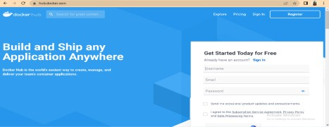

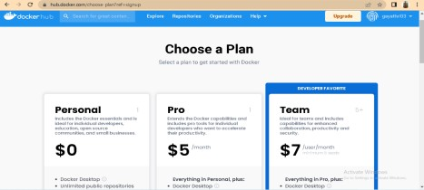

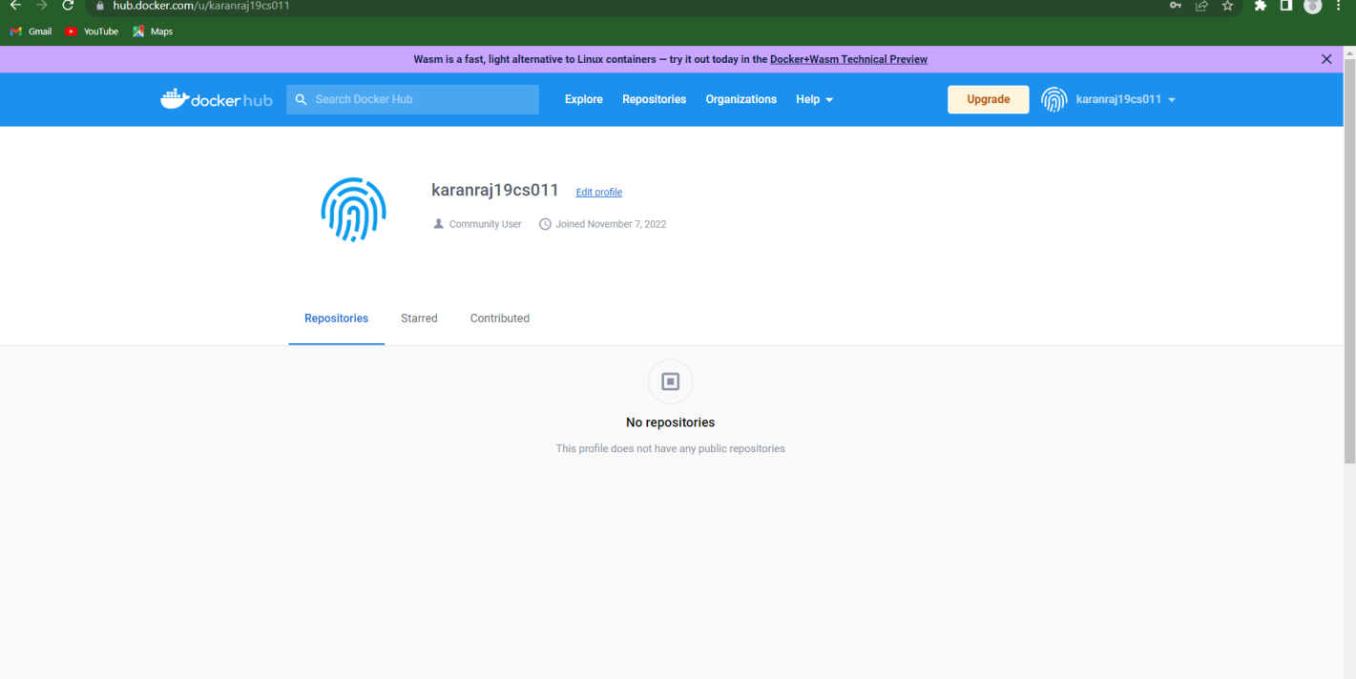

**Step 3.** Open Docker Desktop and start creating containers and images

